How to run the Online Library management System Django Python
1. Download the zip file
2. Extract the file, copy library folder, and paste it on the desktop
3. Open MySQL Create a database olmspythondb then import the SQL File available in the SQL File Folder (For MySQL we used XAMPP server)
4. Open PyCharm and click on the terminal
5. Navigate the project folder using the cd command
cd project_path
For ex: cd C:\Users\ANUJ\OneDrive\Desktop\library\

6. Now Navigate to the olms folder

cd olms

7. Run the Project using the following command
python manage.py runserver
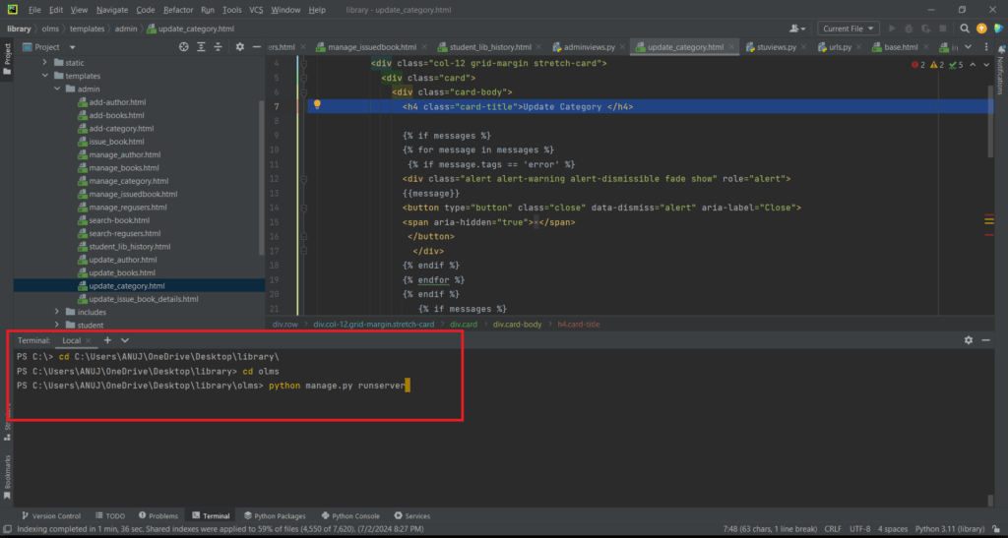
Now click the URL http://127.0.0.1:8000 and the Project will run

Login Details

*************admin************
Username: admin
Password: Test@123

*************User/Student**************
Username: john12345
Password: Test@123 or Register a new Student

